Skip Lists: A guide

What is a skip list
The ordinary linked list has a serious drawback: it requires sequential scanning to locate an element searched for. The search starts from the beginning of the list and ends when the element search is found or when the end of the list is reached. To accelerate search, we can sort the elements in a linked list, but sequential search is still required. This means that we need $O(n)$ time to find, insert, or delete an element in the sorted linked list.
A skip list is a probabilistic data structure that allows for fast search, insertion, and deletion within an ordered sequence of elements. It is a variant of a sorted linked list, and is a simpler alternative to balanced binary search trees (e.g. AVL or Red-Black Trees). It was introduced by William Pugh in 1990 . Skip lists achieve similar average performance as balanced trees but are easier to implement due to probabilistic balancing.
Here is an example of a sorted linked list:
To implement a skip list, we can add a second, “fast level” of pointers, like this:
Or even another, “extra fast level”, like this:
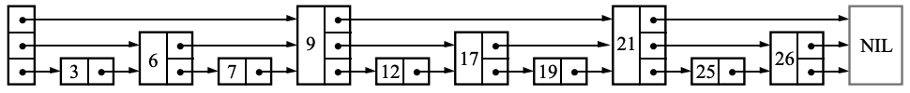
Skip lists are just sorted linked lists with additional layers, which skip over elements, enabling faster traversal. Think of it as express lanes on a highway. The lowest level 0 contains every element and is the slow lane. Each higher level contains only a subset of elements and is a faster lane.
In a skip list, each element is represented by a node, the level of which is chosen when the node is inserted. A node of level $i$has $i+1$ forward pointers — one for each level from $0$ up to $i$.
A key element of the skip list is that, every level $i$ contains only half the elements of level $i-1$. In a randomized skip list, each node is promoted independently to the next level with a probability $p=0.5$ In this way, level $0$ includes all nodes, and on average, level $1$ includes only ½ of the nodes, level $2$ includes only ¼ of the nodes, and so on. The number of levels is capped at some appropriate constant $MaxLevel$.
The distribution of nodes to levels and the express lanes we create by adding a level allow us to insert, search, and delete elements from the skip list at $O(logn)$ on average, and $O(n)$ at the worst case.

Skip List Insertion Process
Suppose we have this skip list with 4 levels, and we want to insert 17:
We first traverse the skip list looking for the insertion point. We start searching for 17 from the highest level. If the next node is $<17$, we move right at the same level. If the next node is $≥17$, we move down a level. We end up at the node with the value 12.
We then select a random level for the new node. Suppose the level is $2$. We insert the new node and re-wire all pointers of predecessor nodes at all levels $≤2$.

Skip List Deletion Process
Suppose we have the same skip list as before, with 4 levels, and we want to delete 17:
Same as for insertion, we first traverse the skip list looking for 17. We start searching for 17 from the highest level. If the next node is $<17$, we move right at the same level. If the next node is $≥17$, we move down a level. We end up at the node that we want to delete at level $0$, with a tower of pointers up to level $2$.
Once we delete the node, we re-wire all pointers of predecessor nodes at all levels $≤2$.

Pugh, William. "Skip lists: a probabilistic alternative to balanced trees." Communications of the ACM 33, no. 6 (1990): 668-676.

